Question 1
Q. How do you render a list of items in React? Why is it important to use keys when rendering lists?
Ans : Rendering A List:
- In React, You Render Lists By Using The JavaScript map() Method To Transform An Array Into JSX Elements.
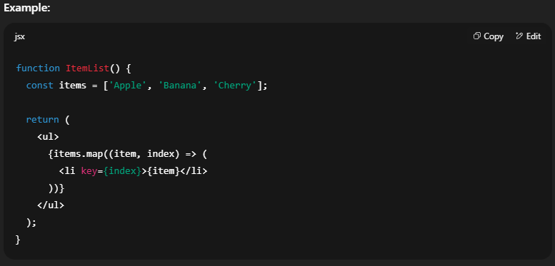
Importance Of Using Keys:
- Keys Help React Identify Which Items Have Changed, Been Added, Or Removed.
- Improves Rendering Performance And Avoids Unnecessary Re-renders.
- Without Keys, React May Reuse Wrong DOM Elements, Causing UI Bugs.

Question 2
Q. : What are keys in React, and what happens if you do not provide a unique key?
Ans : Definition Of Keys:
- A Key Is A Special String Attribute Assigned To Elements In A List.
- It Should Be Unique Among Siblings In The List.
What Happens If You Don’t Provide A Unique Key:
- React Falls Back To Using Array Index As Key, Which Can Cause Rendering Issues.
- If List Order Changes, Elements Might Not Update Correctly.
- Can Lead To Unexpected Behavior In Controlled Inputs Or Animated Lists.
Best Practice:
- Use A Unique Identifier From Your Data (Like id From Database) Instead Of Index Whenever Possible.

